**Assignment No:-29**

Name:-Suryawanshi Sangramsingh Sambhaji

Batch: - Delta - DCA (Java) 2024 Date:-16/6/2024

**Q1.Wap enter a string and print it in a reverse order word by word.**

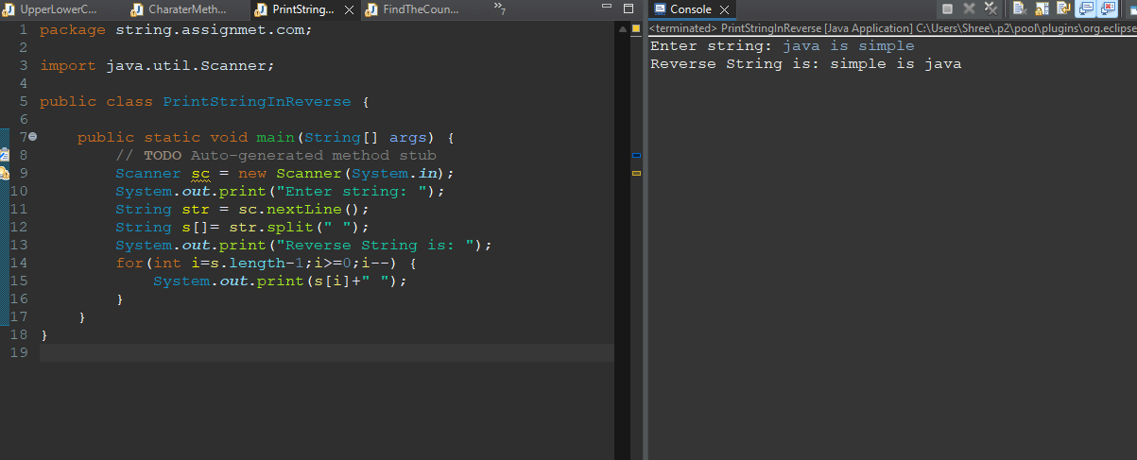

**Q2.Wap enter a string and find the count of word and character(excluding space).**

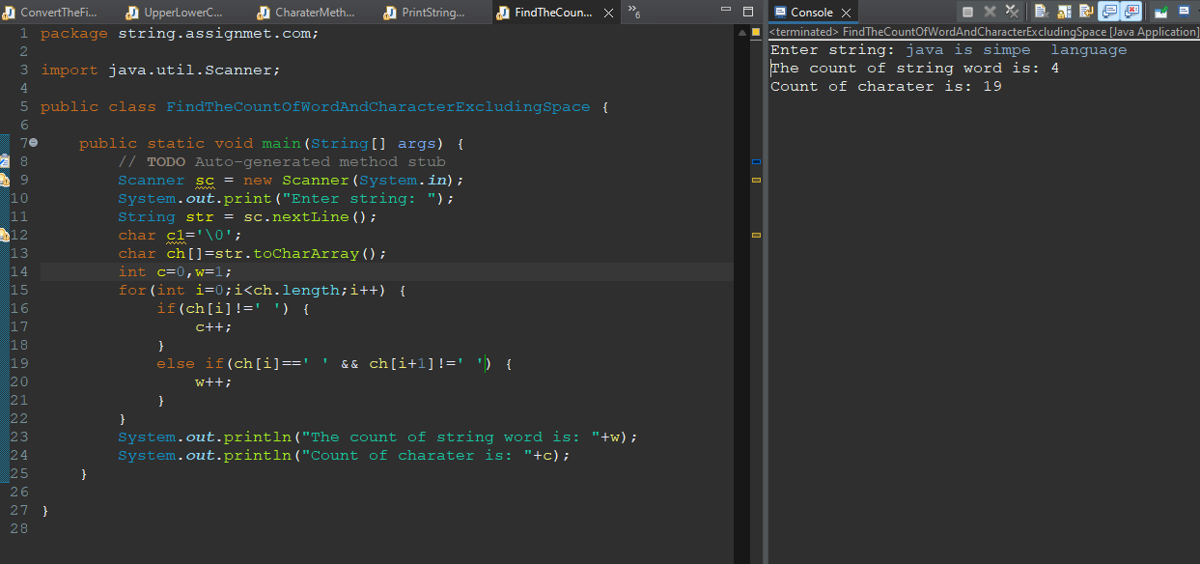

**Q3.Wap input a string and print only those word which first character is vowel.**

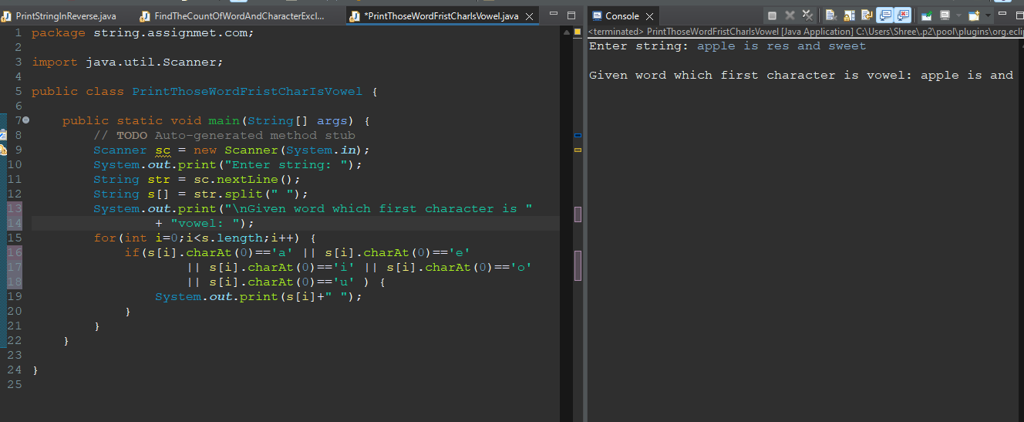

**Q4.Wap enter a string and sort each word of string in ascending and descending order by the length of each word.**

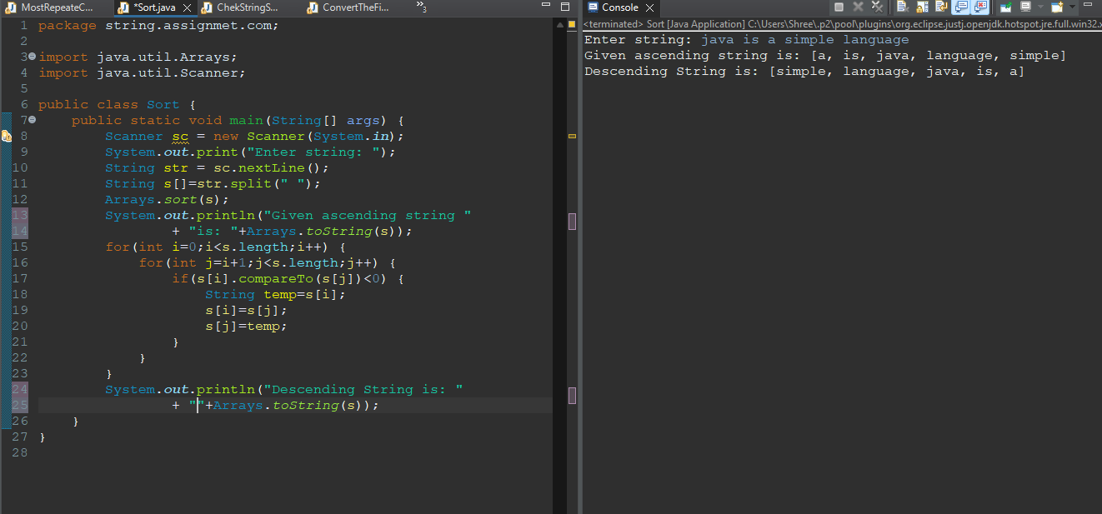

**Q5.Wap enter a string in lowercase now you have to convert every first character of the word in upper case.**

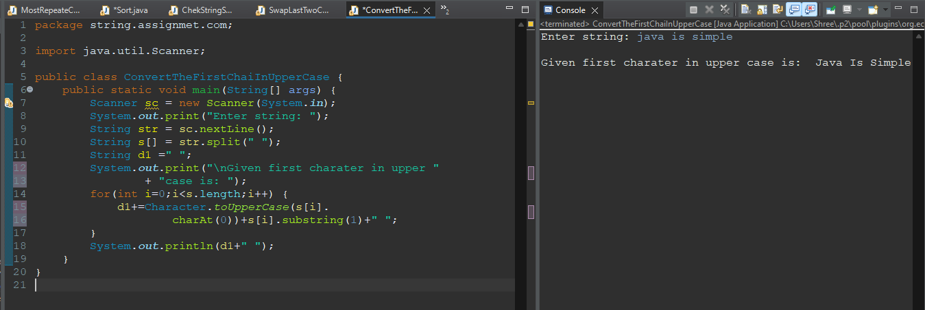

**Q6.Wap enter a string and print first non-repeating character using class and object.**

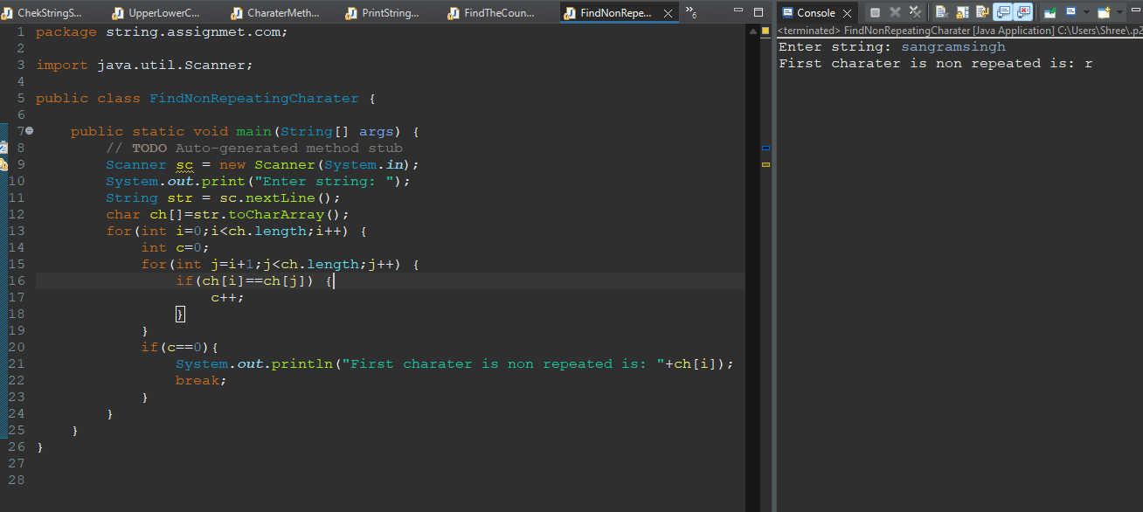

**Q7.Wap enter a string and check it is anagram or not constructor and using class and object.**

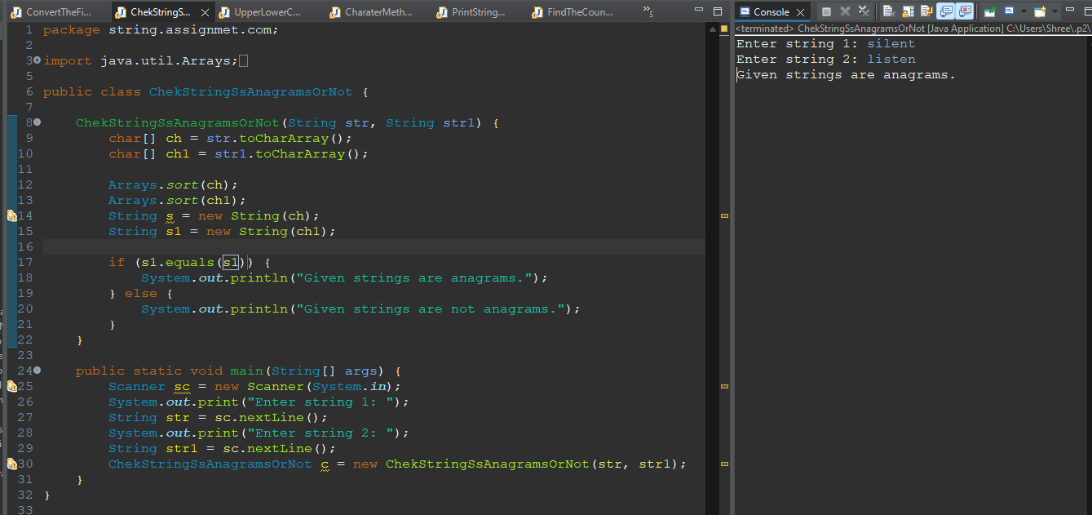

**Q8.Wap enter a string and print most repeated character in string.**

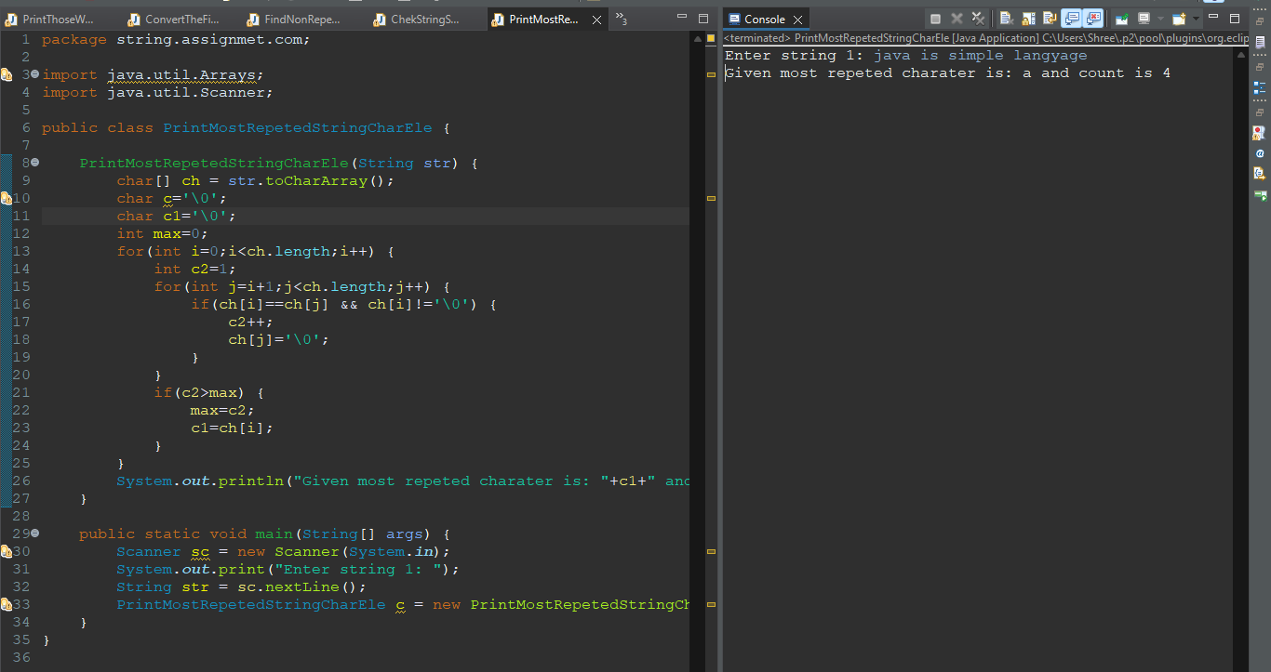

**Q9. Write a Java program to create a new string from a given string swapping the last two**

**Characters of the given string. The length of the given string must be two or more.**

**Sample Output:**

**The given strings is: string**

**The string after swap last two characters are: strign**

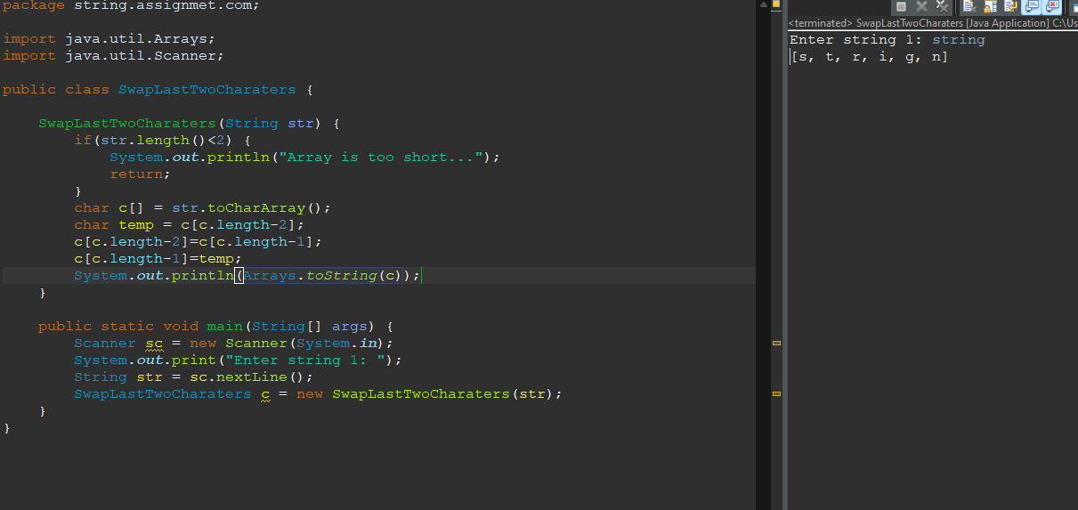

**Q10. Write a Java program to read a given string and if the first or last characters are same**

**Return the string without those characters otherwise return the string unchanged**

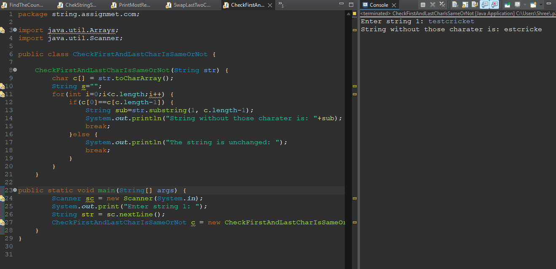

**Q11.Wap enter a string and find the percentage of uppercase, lowercase, digits and special characters in a string.**

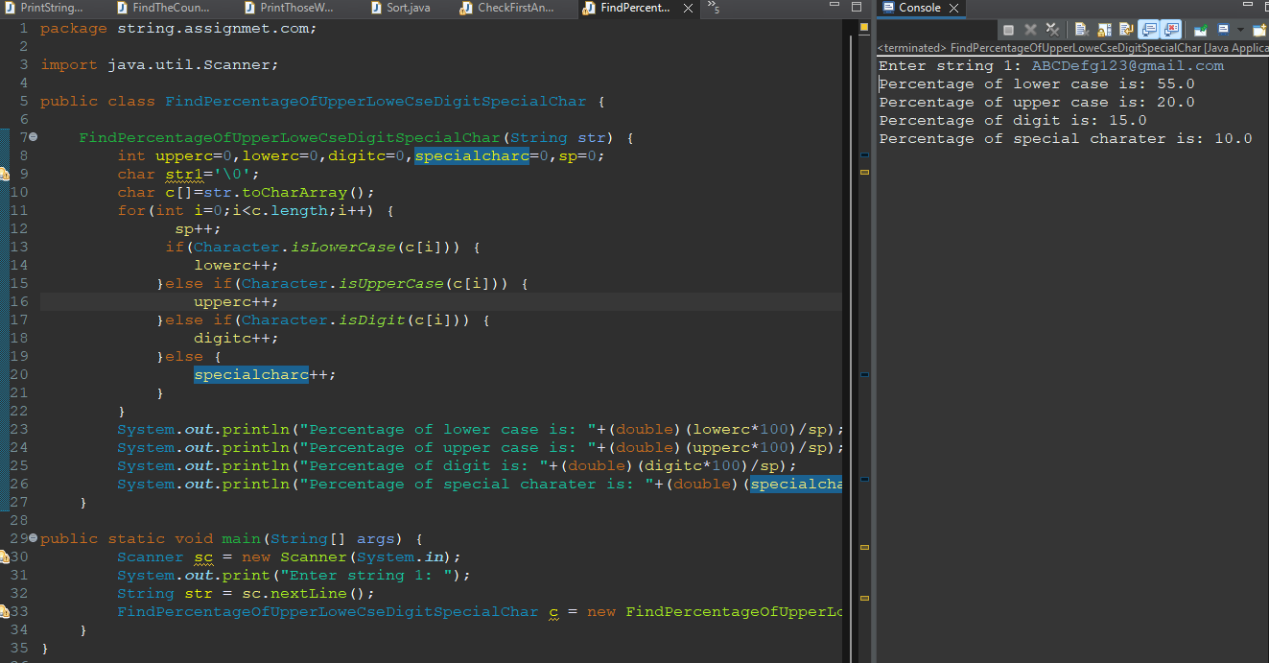

**Q12. Write a Java program to read a given string and if the first or last characters are same**

**return the string without those characters otherwise return the string unchanged.**

**Sample Output:**

**The given strings is: testcricket**

**The new string is: estcricke**



**Q13. Write a Java program to create a new string repeating every character twice of a**

**given string.**

**Sample Output:**

**The given string is: welcome**

**The new string is: wweellccoomme**

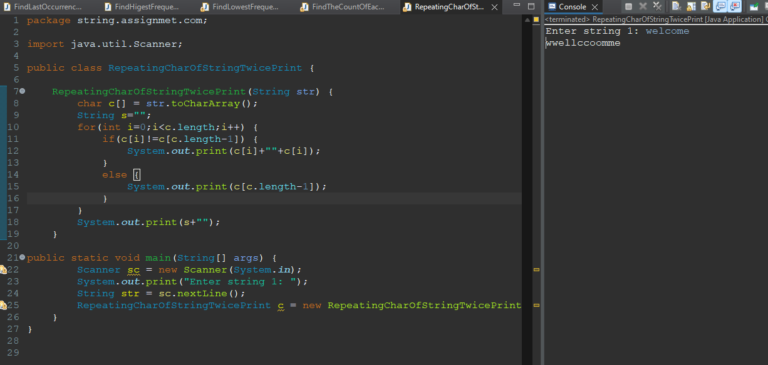

**Q14.Wap enter a string and find the occurrence of first word, first character, last word, last character in string by using class and object.**

